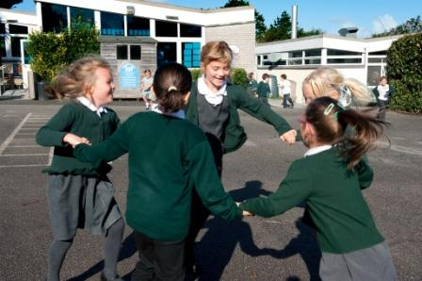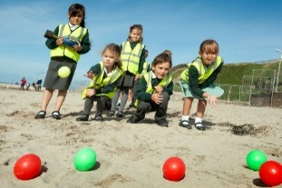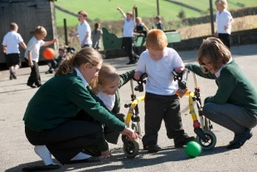
Perranporth C P School

SMSC Policy
Sept 2018 – to be reviewed Sept 2020
– Our Vision –
Through a positive caring environment, we provide the opportunity for every child to reach their full potential. We embrace the Children’s Rights of the Child through our UNICEF Rights Respecting School learning and assessmblies .

1 Aims and objectives
1.1 At Perranporth Primary School we strive to create a learning environment which promotes respects, diversity and self-awareness and equips all of our pupils with the knowledge, skills, attitudes and values they will need to succeed in their future lives.
1.2 We follow the Inspire Curriculum which provides a wide range of artistic, sporting and cultural opportunities that encourage pupils to work together and use imagination in their learning. Activities are planned that require pupils to reflect and empathize with others as well as giving them the confidence to provide their opinions and develop their own view points. Teachers provide children with a weekly class debate or Rights Respecting session. These are opportunities for children to learn more about their rights, World issues, morals and values. Class debates also teach children to share and listen to different opinions on a range of subjects and challenge viewpoints in a calm and considerate manner.
2 Spiritual Development
2.1 Definition
Spiritual development focuses on an individual’s own personal beliefs and values and their resulting behaviours. Through spiritual development, children are able to understand their own feelings and emotions and this enables them to reflect and to learn.
2.2 Our learning environment and curriculum
Curriculum opportunities enable pupils to:
• Be curious and to express feelings of delight and wonder, (scientific investigations, new life, the global landscape)
• Empathise and consider the viewpoints of others, (RRSA learning, debates, drama activities, discussing feelings and empathising with characters in familiar stories)
• Consider how a belief can change people’s lifestyles, (R.E, investigating communities and faiths, historical case studies)
• Discuss what they think they have achieved and what they need to do to be successful in the future, (Building Learning Power, self-assessment, target setting activities).

3 Moral Development
3.1 Definition
Moral development means exploring, understanding and recognising shared values and considering the issues of right and wrong.
3.2 Our learning environment and curriculum
The classroom environment and curriculum promote moral development through:
• The adoption of ‘Class Rights’ and class rules, agreed with children and displayed in the classroom
• Clear and consistent rewards and sanctions that children understand and believe to be fair.
• Class and school assemblies that discuss children’s rights, moral values and cite expectations.
• Activities that enable pupils to give opinions and show their values (class debates, RRS learning).
• Discussing the choices made by the pupils and others and the resulting outcomes, character studies, studies of historical figures).
• Justice and forgiveness are taught and modelled throughout the school using our school rules and stories in assemblies.

4 Social Development
4.1 Definition
Social development involves learners working effectively together and participating successfully in the school community as a whole. During a pupil’s social development they gain interpersonal skills that allow them to form successful relationships and to become a positive team member.
4.2 Our learning environment and curriculum
At Perranporth Primary School social skills are developed through:
• Modelling of positive social behaviour by all staff
• After school clubs
• Sporting activities
• Team games at play times and lunch times
• Turn taking and team building activities
• Pair and small group work within the classroom
• Working with others across the local community (local care homes, cluster schools, local sports college, Open the Book Worship team)
4.3
Friendship, generosity, trust, courage and perseverance are taught and modelled throughout the school in learning time such as circle time, assemblies, debates and BLP learning.

5 Cultural Development
5.1 Definition
Cultural development enables learner’s to develop an understanding of their own culture and of other cultures locally, nationally and internationally. It also means learning to feel comfortable in a variety of cultures and valuing cultural diversity.
5.2 Our learning environment and curriculum
Children are introduced to a regional and global perspective in life through:
• Links with local and Rights Respecting Schools learning
• Stories from different cultures
• First hand experiences through local visits, art and artists
• Visitors from the local and international community
• Being part of National and International fund raising events
• Studies of a different lifestyle including different food, dress, festivals and places of worship.
• Learning about other cultures when raising money for charity
• Children are taught to understand the lifestyles and choices made by the variety of different cultures and faiths that exist within the school.
8 Monitoring and review
8.1 The planning and coordination of SMSC are the responsibility of the RE subject leader, who also:
• Supports colleagues in their teaching, by keeping informed about current developments in the subject, and by providing a strategic lead and direction for SMSC;
• Speaks to the children about different elements of SMSC and uses this to inform future planning.
• Reviews the planning of SMSC across the curriculum, evidence of the children’s work and to observe elements of SMSC across the school.
• Plans regular staff meetings to explore identified values and the SMSC links that may exist within these.

