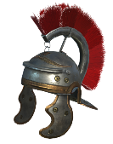
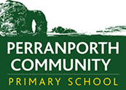
History Scheme of Work
Perranporth C P School
Year 3 Autumn Term
 | AUTUMN 1st Half |  |  |  |  | Autumn 2nd Half
Theme | Through the Ages (The Stone Age) |  |  |  |  | Tremors
British Key Question | How has modern Britain been shaped by our Prehistoric ancestors? |  |  |  |  | Why live in Natural Disaster Hotspots? Would you?
Enhancements | Trip: Visit to Penlee Gallery |  |  |  |  | Trip: Launch at beach to search for rocks – have some rocks selectively hidden on location – this can be adapted for in school launch on field/in environmental area.  Visitor  Walk:
Books | Stone Age Boy- Satoshi Kitamura |  |  |  |  | The Firework Maker’s Daughter, Philip Pullman (novel study)
Addressing Stereotypes | Satoshi Kitamura- Race/Ethnicity
British Values | Democracy – difference between then and now – why the change?  Rule of Law – difference between then and now – why the change?  Individual Liberty – difference between then and now – why the change?  Mutual Respect & Tolerance – difference between then and now – why the change? |  |  |  |  | Democracy –  Rule of Law –  Individual Liberty –  Mutual Respect & Tolerance –
History  (All NC subject content covered) | Pupils should continue to develop a chronologically secure knowledge and understanding of British, local and world history, establishing clear narratives within and across the periods they study. They should note connections, contrasts and trends over time and develop the appropriate use of historical terms. They should regularly address and sometimes devise historically valid questions about change, cause, similarity and difference, and significance. They should construct informed responses that involve thoughtful selection and organisation of relevant historical information. They should understand how our knowledge of the past is constructed from a range of sources.  Pupils should be taught about changes in Britain from the Stone Age to the Iron Age. |  |  |  |  | Pupils should continue to develop a chronologically secure knowledge and understanding of British, local and world history, establishing clear narratives within and across the periods they study. They should note connections, contrasts and trends over time and develop the appropriate use of historical terms. They should regularly address and sometimes devise historically valid questions about change, cause, similarity and difference, and significance. They should construct informed responses that involve thoughtful selection and organisation of relevant historical information. They should understand how our knowledge of the past is constructed from a range of sources.  Pupils should be taught about changes in Britain from the Stone Age to the Iron Age.
Key Historical Skills to be Taught | H-Y3K1.1  H-Y3K1.3  H-Y3K1.4  H-Y3K1.5 | H-Y3C2.1  H-Y3C2.2  H-Y3C2.3  H-Y3C2.4 | H-Y3I3.1  H-Y3I3.2  H-Y3I3.3  H-Y3I3.4 | H-Y3E4.1  H-Y3E4.2  H-Y3E4.3  H-Y3E4.4  H-Y3E4.5 | H-Y3OC5.1  H-Y3OC5.2  H-Y3OC5.3 | H-Y3K1.3  H-Y3K1.4  H-Y3K1.5 | H-Y3C2.3  H-Y3C2.4 | H-Y3I3.2 | H-Y3E4.1  H-Y3E4.3  H-Y3E4.4  H-Y3E4.5 | H-Y3OC5.1  H-Y3OC5.2
Key questions / knowledge and understanding to be explained  Key Knowledge and facts to be recalled | Where do the Stone Age, Bronze Age and Iron Age fit chronologically on a timeline?  •The Stone Age, Bronze Age and Iron Age covers 98% of human history in Britain - around 750,000 years!  • Prehistory in Britain started c750,000 BC, when several species of humans arrived from Europe.  - Prehistory is divided into three main periods, the Stone Age, Bronze Age and Iron Age. Each period is named after the main material used to make tools at that time.  - Stone Age – oldest and longest period, lasting 747,000 years  - Bronze Age came next, starting c2500BC, lasting 1700 years.  - Last period was Iron Age, beginning 800BC, lasting until AD 43 (843 years) The Romans came after this period (Year 4 topic).  What was life like for someone living in the Stone Age?  - Tools and weapons – Tools were made from stone, wood and bone. They were used for digging, hunting and chopping.  - Everyday life – Stone Age people were hunter-gatherers. They followed and killed animals and gathered seasonal food. They made clothes from animal skins and created cave art.  - Settlements – People lived in temporary shelters or caves in the Palaeolithic. People lived in more permanent settlements in the Neolithic (at the end of the Stone Age).  - Beliefs – People built monuments, including stone circles, henges and earthworks. Historians believe that they used these monuments for gatherings and worship.  - End of the Stone Age – The Beaker folk arrived from Europe and brought their knowledge of metalworking to Britain.  What was life like for someone living in the Bronze Age?  - Tools and weapons – Bronze tools were sharper, stronger and more efficient than stone tools. Bronze tools were owned by the wealthy.  - Everyday life – The Beaker folk brought their knowledge of metalworking and pottery making to Britain. Bronze tools made farming more efficient, so there was more food and the population grew.  - Settlements – People lived in permanent settlements, in roundhouses. They used walls and fences to protect their homes.  - Beliefs – People were buried with objects, including Bell Beaker pottery, to use in the afterlife. They threw weapons and objects into rivers as offerings to the gods.  - End of the Bronze Age – People stopped using metal during a time called the Bronze Age collapse.  What was life like for someone living in the Iron Age?  - Tools and Weapons – Iron tools and weapons were sharp and strong. Everyone could own iron tools and weapons, not just the wealthy.  - Everyday life - Iron tools made farming more efficient and iron weapons were available to everyone. Tribes attacked each other to steal their land, food and possessions. People created art, music and poetry.  - Settlements - People lived in hillforts surrounded by ditches and fences to stop attacks from enemy tribes. People lived in roundhouses inside the hillfort and farmed the land outside.  - Beliefs - Priests called druids led worship. Humans were sacrificed as offerings to the gods. People threw votive offerings into rivers and lakes.  - End of the Iron Age - The Romans invaded and conquered Britain in AD 43. They created written records, so this event ended prehistory in Britain.  How did Britain change from the Stone Age to the Iron Age?  • The change from hunter-gatherer to settlements  •The change in climate effecting what was hunted, used and eaten.  •The development of tools as metals were mined and made – LINK TO CORNISH TIN MINING.  How has life in the stone, bronze and iron ages impacted on our lives today?  •Some of the major advances in technology were achieved during this period, such as control of fire, metalworking and farming, and the development of the wheel, without which our modern life would not be possible.  •Some believe that British culture, though disturbed and modified by incursions of Romans, Anglo-Saxons and Vikings, was also forged in this period, including British belief in individual freedom.  •The development of the economy from a mobile hunter-gatherer lifestyle to settled farming, contrasting long distance trade and gift exchange to the adoption of coinage can all be explored in this period. |  |  |  |  | Outline of Learning Focus:  - Historical Natural Disasters – focus on Pompeii, but also referring to recent events – locate Pompeii on European map and Italian map, using symbols to identify other key cities/countries.  - Mount Vesuvius in Italy erupted in AD 79 (not long after the Romans had started to inhabit Britain).  Modern Day Natural Disasters to identify and timeline (add as they occur):  - Boxing Day tsunami, Indian Ocean 2004.  - 2019-20 Australian Bush fires  - New Zealand – 2020, 2016…  - Icelandic Volcanic Ash Cloud, 2011 – Eyjafjallajokull.  - Local natural disasters – Bsocastle flooding 2004.
Vocabulary | Content Specific:  - Stone Age  - Bronze Age  - Iron Age  - Hunter-gatherer  - Skara Brae  - Stonehenge  - Hill fort  - Druid  - Celts  - Beaker Folk  - Sacrifice  - Torc  - Votive offering |  |  | Subject Specific:  - Era/period  - Century  - Millennium  - BCE (Before Common  - Era)  - CE (Common Era)  - BC (Before Christ)  - AD (Anno Domini)  - Archaeologists / archaeology  - Museum  - Pre-history  - Bias  - Excavate |  | Content Specific: |  | Subject Specific:
Outdoor Learning | Environmental area as a base for recreating ‘Stone Age, Bronze Age and Iron Age’ drama and art. Create a class piece of art - https://www.english-heritage.org.uk/visit/places/uffington-castle-white-horse-and-dragon-hill/ |  |  |  |  | Beach visit to explore rock types and how sand is formed.
Other Provision

Year 3 Spring Term
 | Spring 1st Half |  |  |  |  | Spring 2nd Half
Theme | Predators |  |  |  |  | Cornwall Charity - Shelterbox
British Key Question | Are Britain’s predators under threat? |  |  |  |  | What is charity and what can we do to help?
Enhancements | Visit from animal expert – national marine aquarium, Falmouth |  |  |  |  | Visit from a ShelterBox/RNLI representative  Beach and town safety audit
Books | Classic Literature – The Lion, The Witch and The Wardrobe, CS Lewis. |  |  |  |  | Mousehole Cat and other Cornish myths and legends, including St Piran.
Addressing Stereotypes | Are Britain’s predators under threat? |  |  |  |  | What is charity and what can we do to help?
British Values | Democracy – Is the lion the king of the jungle or should other animals have a say?  Rule of Law – Should we test on animals?  Individual liberty – Are zoos fair?  Mutual Respect and Tolerance – Are dangerous dogs or owners to blame? |  |  |  |  | Democracy – Give to the UK or elsewhere, who decides?  Rule of Law – Give to the UK or elsewhere, who decides?  Individual Liberty – would you live near a natural disaster?  Mutual Respect & Tolerance - Give to the UK or elsewhere, who decides?
History
(All NC subject content covered)
Key Historical Skills to be Taught
Key questions / knowledge and understanding to be explained
Key Knowledge and facts to be recalled
Vocabulary | Content Specific: |  | Subject Specific: |  |  | Content Specific: |  | Subject Specific:
Outdoor Learning

Year 3 Summer Term
 | Summer 1st Half |  |  |  |  | Summer 2nd Half
Theme | Gods and Mortals (The Greeks) |  |  |  |  | Flow
British Key Question | What impact did the Ancient Greeks have on modern democracy? |  |  |  |  | Are rivers and the sea, the place to be?
Enhancements | Athens Vs Sparta Battle as a launch  Sports Day inspired Olympics |  |  |  |  | Local River Study – River Menalhyl, St Mawgan.  Perranporth Beach visit – flood defence and plastic mini-project
Books | The Iron Man  Percy Jackson and the Lightning Thief  Selection of Ancient Greek Myths and Legends – Pandora, Theseus, Trojan Horse. |  |  |  |  | Journey to the River Sea (novel study)  The River, Valerie Bloom  Eva Ibbotson
Addressing Stereotypes | Universal suffrage/right to vote (his)  Comparing the rights of men/women in  Athens/Sparta/Modern Britain (his) |  |  |  |  | Maia, female (young girl) lead character in novel study text.
British Values | Democracy – Were there equal rights for all?  Rule of Law – Were slaves covered by the same laws as everyone else?  Individual Liberty – Could a Spartan become a philosopher?  Mutual Respect & Tolerance – What if a Spartan refuse to fight? |  |  |  |  | Democracy – Should you pay to fish in the river/slash?  Rule of Law – Should we limit the number of people who visit a beach?  Individual Liberty – Can water be stolen?  Mutual Respect & Tolerance – Can you harm a river?
History  (All NC subject content covered) | Pupils should continue to develop a chronologically secure knowledge and understanding of British, local and world history, establishing clear narratives within and across the periods they study. They should note connections, contrasts and trends over time and develop the appropriate use of historical terms. They should regularly address and sometimes devise historically valid questions about change, cause, similarity and difference, and significance. They should construct informed responses that involve thoughtful selection and organisation of relevant historical information. They should understand how our knowledge of the past is constructed from a range of sources.  Pupils should be taught about Ancient Greece – a study of Greek life and achievements and their influence on the western world. |  |  |  |  | Pupils should continue to develop a chronologically secure knowledge and understanding of British, local and world history, establishing clear narratives within and across the periods they study. They should note connections, contrasts and trends over time and develop the appropriate use of historical terms. They should regularly address and sometimes devise historically valid questions about change, cause, similarity and difference, and significance. They should construct informed responses that involve thoughtful selection and organisation of relevant historical information. They should understand how our knowledge of the past is constructed from a range of sources.  Pupils should be taught about Ancient Greece – a study of Greek life and achievements and their influence on the western world.
Key Historical Skills to be Taught | H-Y3K1.2  H-Y3K1.3  H-Y3K1.4  H-Y3K1.5 | H-Y3C2.1  H-Y3C2.2  H-Y3C2.3  H-Y3C2.4 | H-Y3I3.1  H-Y3I3.2  H-Y3I3.3  H-Y3I3.4 | H-Y3E4.1  H-Y3E4.2  H-Y3E4.3  H-Y3E4.4  H-Y3E4.5 | H-Y3OC5.1  H-Y3OC5.2  H-Y3OC5.3
Key questions / knowledge and understanding to be explained  Key Knowledge and facts to be recalled | 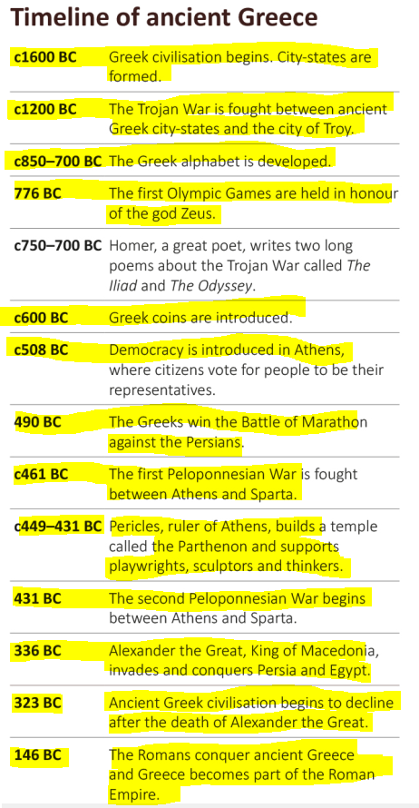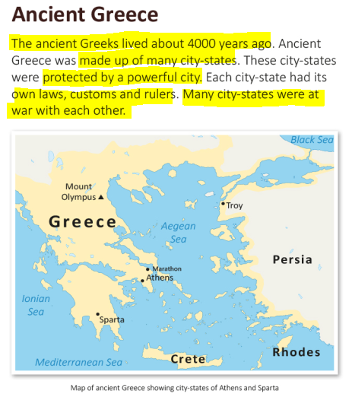  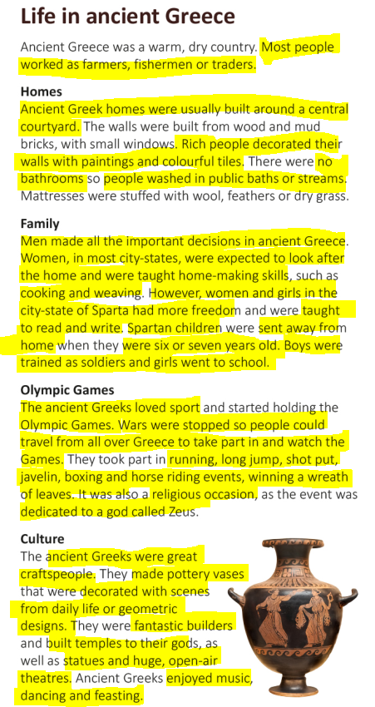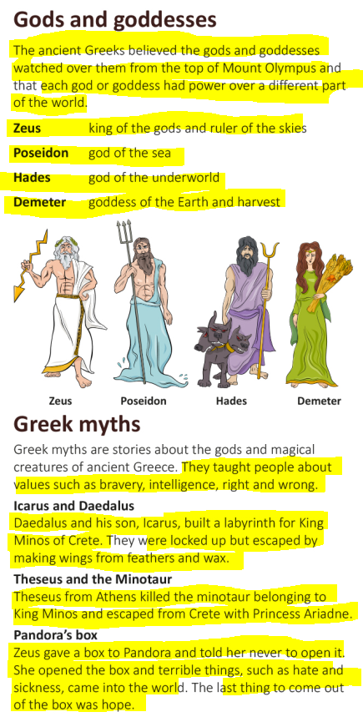  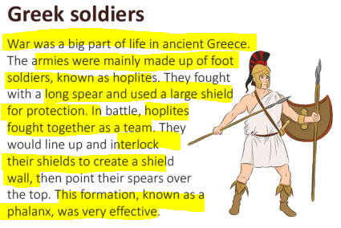  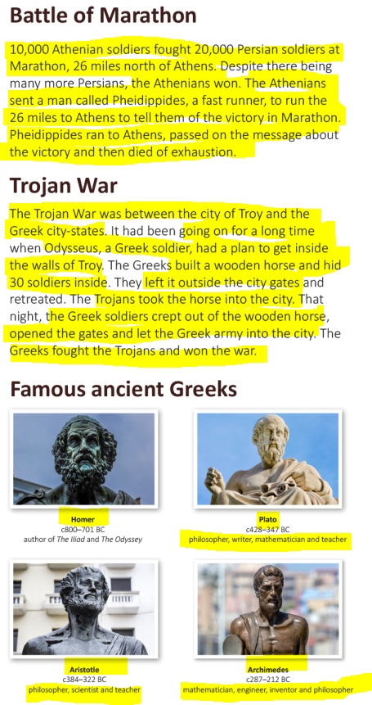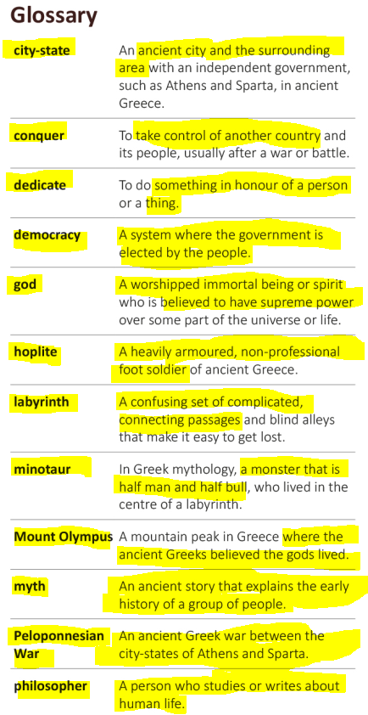  How has Ancient Greece impacted on our lives today?  - The Ancient Greeks have given a huge legacy to modern Europe: Civilisation, democracy, scientific and mathematical knowledge and written history  - Our system of government, and most systems around the world, is based on democracy, invented by the Greeks.  - Much of mathematics has its roots in the work of Greeks in this period  - The three greatest ancient Greek philosophers were Aristotle, Plato, and Socrates. Socrates taught Plato, then Plato taught Aristotle. These three thinkers turned early Greek philosophy into the beginnings of Western philosophy as it is today. Aristotle taught Alexander the Great.  - Aristotle thought that knowledge from the senses was very important. These thoughts became some of the roots of the scientific method used for hundreds of years.  - Plato was Aristotle’s teacher. He wrote about many ideas in philosophy that are still talked about today. Plato wrote his books in the form of people talking about ideas, and sometimes disagreeing about them. This makes his books more interesting to read.  - Socrates was Plato’s teacher. He showed how argument, debate, and discussion could help people to understand difficult issues.  - The Greeks were one of the first to write history down and study it. The reason we are in a history lesson today is because of the Greeks!  - Many towns and cities will have some elements of architecture in Greek style, including Ionic, Doric and Corinthian columns.  - Many Greek myths are still told as stories today.  - Every four years the Greeks held a special sporting festival at Olympia - the Olympic Games. These inspired the modern Olympics which began in 1896. Some of the events were very similar. Like the Greeks, we also hold the Olympics every four years.
Vocabulary | Content Specific:  - Greek  - Democracy  - Architecture  - Alexander the Great  - Socrates  - Plato  - Aristotle  - Sparta / Spartan  - Athens / Athenian  - Slave  - Myth  - Olympics |  | Subject Specific:  - impact  - effects  - consequences  - continuity  - cause / causation  - infer  - conclusion |  |  | Content Specific: |  |  | Subject Specific:
Outdoor Learning | Sparta v Athens battle launch and Olympic Sports Festival Legacy. |  |  |  |  | Local river study at topic launch, Perranporth Beach visit for flood defence research and plastic investigation.

