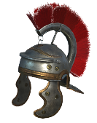
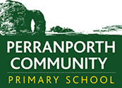
History Scheme of Work
Perranporth C P School
Year 5 Autumn Term
 | AUTUMN 1st Half |  |  | Autumn 2nd Half
Theme | Pharaohs |  |  | Rainforest
British Key Question | Are the British grave robbers? |  |  | Can Britain save the rainforest?
Enhancements | Egyptian mummification day  Truro Museum – artefacts |  |  | Trip to the Eden Project  Christmas Play fundraiser
Books | Holes by Louis Sachar |  |  | The Explorer by Catherine Rundell
Addressing Stereotypes | Cleopatra – Powerful woman |  |  | Tribes – the role of men and women
British Values | Democracy – Ancient Egyptian hierarchy  Rule of Law – Are we within the law to have taken ancient Egyptian artefacts?  Individual Liberty – Did ancient Egypt have individual liberty like we do?  Mutual Respect & Tolerance – Differences in beliefs about the after life |  |  | Democracy – Tribes hierarchy  Rule of Law – Deforestation  Individual Liberty – Should we be allowed to destroy the rainforest  Mutual Respect & Tolerance – Does the World respect the rainforest and its inhabitants?
History  (All NC subject content covered) | Pupils should be taught about:  - Pupils should be taught about the achievements of the earliest civilizations – an overview of where and when the first civilizations appeared.  - Pupils should continue to develop a chronologically secure knowledge and understanding of British, local and world history, establishing clear narratives within and across the periods they study. They should note connections, contrasts and trends over time and develop the appropriate use of historical terms. They should regularly address and sometimes devise historically valid questions about change, cause, similarity and difference, and significance. They should construct informed responses that involve thoughtful selection and organisation of relevant historical information. They should understand how our knowledge of the past is constructed from a range of sources. |  |  | Pupils should be taught about:
Key Historical Skills to be Taught | H-Y5K1.1  H-Y5C2.1  H-Y5C2.2  H-Y5C2.3 | H-Y5C2.4  H-Y5I3.1  H-Y5E4.1  H-Y5E4.2  H-Y5E4.3  H-Y5E4.4 | H-Y5OC5.1  H-Y5OC5.2  H-Y5OC5.3 | H-Y5K1.1 | H-Y5I3.1 | H-Y5E4.1  H-Y5E4.2  H-Y5E4.3  H-Y5E4.4
Key questions / knowledge and understanding to be explained  Key Knowledge and facts to be recalled | - Life in Ancient Egypt  The Nile played an important part in the daily life of the ancient Egyptians. It provided water, food transportation and excellent soil for growing food.  The people of Ancient Egypt built cities, temples palaces and pyramids on both sides of the river and created a great civilisation. The Egyptian people were ruled by a pharaoh. Pharaohs were the richest and most powerful kings or queens and were believed to be the messengers of the gods. The rest of the people were organised in to a very strict hierarchal system of viziers; nobles; scribes; priests; farmers; craftspeople and soldiers; peasants and slaves.  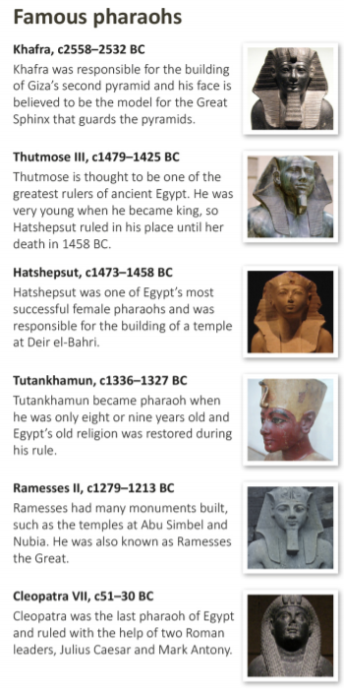  - Who were the most famous pharaohs?  - Who were the Egyptian gods?  Ancient Egyptians believed that many different gods and goddesses controlled the world. They were thought to look like humans and animals and each god represented a different aspect of life in Ancient Egypt. The Egyptians performed rituals and built temples to honour the gods.  Ra was the most important Egyptian god. He was god of the sun and was thought to be reborn every morning.  Anubis was the god of embalming and the dead. He had the head of a jackal and the body of a man.  Ma’at was the goddess of truth, justice and harmony. She symbolised the balance of life on Earth.  Tefnut was the goddess of moisture and the mother of the sky and the Earth. She had the head of a lioness.  - How did the ancient Egyptians write?  Ancient Egyptians writing is called hieroglyphics. Hieroglyphics use pictures to represent different objects, sounds, actions and ideas. Each character is known as a hieroglyph. There are more than 700 hieroglyphs.  - What is the afterlife?  One of the key beliefs in ancient Egypt was that when a person died, their spirit would live again in the afterlife. The ancient Egyptians had special rituals to prepare the body, and the dead were buried with possessions that would help them in the afterlife, such as food, drink, clothes and treasures. The pharaohs had huge tombs built to house their bodies and possessions. These tombs are the famous pyramids of Giza that are guarded by a sphinx.  - Who discovered Tutankhamun’s tomb?  A wealthy Englishman, Lord Carnarvon, was interested in ancient Egypt. He paid for an archaeologist called Howard Carter and a team of workers to carry out excavations in the Valley of the Kings on the west bank of the Nile, where they discovered Tutankhamun’s tomb. It took Carter’s team 10 years to remove over 3000 items from the tomb. After the discovery, a series of strange events occurred, including the death of Lord Carnarvon. Many believe a curse had been placed on Carter’s team after disturbing the tomb. |  |  | 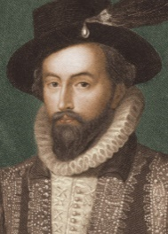  Sir Walter Raleigh  In the 16th century, Sir Walter Raleigh began his search for El Dorado in Guyana’s rainforest. The rainforest in Guyana is a place that has hardly changed since Raleigh’s day and remains one of the few areas of unspoilt jungle anywhere in the world.  Rainforest Tribes  Rainforests are not just home to animals and plants; they are also home to groups of people. There are many tribes of people who call the rainforest home but the most well-known are the Yanomami tribe, the pygmy tribe and the Huli tribe. The Yanomami Tribe live in the South American rainforest.  Indigenous people are currently under threat due to outsiders exploiting the natural resources in the rainforests.  How have the rainforests changed over time?  Big businesses and farming are changing the rainforest and local populations. The Amazon is known as the ‘lungs of the Earth’ so damaging it affects everyone. About 17% of the Amazon rainforest has been destroyed in the past 50 years.  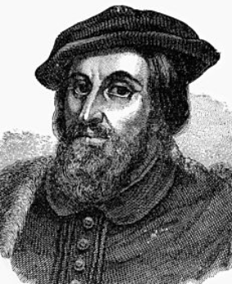  The History of Chocolate  It all starts with the cacao bean. Yes, we spelled that right - cacao is the Spanish word for chcahuatl, which is what Aztecs called the beans chocolate is made from. It’s thought that English traders misspelled cacao when they brought the beans home, and so cocoa stuck.  During the 16th century a man called Hernán Cortés travelled to South America to establish Spanish colonies, and when he arrived he was greeted with gallons of the spicy drink. He took some home with him to Spain and it became a hit.
/Vocabulary | : Archaeologist  Afterlife  Curse  Giza  Hierarchy  Hieroglyphics  Pyramid  Ritual  Sphinx  Tomb  Valley of the Kings  Vizier  Mummification  Canopic jars  The book of the dead  Kha  Merit  Gods  primary source/evidence,  secondary source/evidence,  reliable  extent of change,  evaluate,  reliable,  eye-witness,  legacy  consequences,  decade |  |  | Tribes  Yanomami tribe  Pygmy tribe  Huli Tribe  Indigenous  Natural resources  Hernán Cortés  Sir Walter Raleigh  Deforestation  Exploit  Damage  Cause  Affect  Oxygen  primary source/evidence,  secondary source/evidence,  reliable  extent of change,  extent of continuity evaluate,  reliable,  eye-witness,  Monarchy,  legacy  ambiguous,  consequences,  omits,  decade
Outdoor Learning | Egyptian Hieroglyphics |  |  | Forest School Day

Year 5 Spring Term
 | Spring 1st Half |  |  | Spring 2nd Half
Theme | Stargazers |  |  | Farming and Agriculture in Cornwall
British Key Question | Will the UK ever launch a rocket in to space? |  |  | Kernow Bys Viken?
Enhancements | Planetarium Visit |  |  | Hatching chicks  Scarecrow Competition  Various animal visits  Growing Vegetables
Books | The Girl of Ink and Stars by Kiran Millwood Hargrave |  |  | Charlottes Webb by E.B White
Addressing Stereotypes | The Girl of Ink and Stars – gender inequality |  |  | Women in farming
British Values | Democracy – Who owns space?  Rule of Law – Space Law  Individual Liberty – Would you travel to Space?  Mutual Respect & Tolerance – Should there be a flag on the Moon? |  |  | Democracy – DEFRA  Rule of Law – RSPCA – safety for animals  Individual Liberty – Vegetarian, vegan or meat eater?  Mutual Respect & Tolerance – Respect between humans and animals
History  (All NC subject content covered) | Pupils should be taught about:  A study of an aspect or theme in British history that extends pupils’ chronological knowledge beyond 1066 |  |  | Pupils should be taught about:  A local history study  A study of an aspect or theme in British history that extends pupils’ chronological knowledge beyond 1066
Key Historical Skills to be Taught | H-Y5K1.2  H-Y5K1.4  H-Y5C2.1  H-Y5I3.1 | H-Y5E4.1  H-Y5E4.2  H-Y5E4.3  H-Y5E4.4 | H-Y5OC5.1 | H-Y5K1.5  H-Y5K1.6 | H-Y5E4.2  H-Y5OC5.2
Key questions / knowledge and understanding to be explained  Key Knowledge and facts to be recalled | Isaac Newton (1643-1727)  Isaac Newton formed his theory of gravity when he watched an apple fall from a tree. A newton (N) is a unit of measurement that is used to measure the pull of gravity.  Galileo Galilei (1564-1642)  Galileo Galilei was an Italian scientist and inventor who proved that the Earth orbits the Sun. In 1609, Galileo invented a telescope that he used to observe sunspots that appeared to move across the Sun’s surface. He also observed the craters and mountains on the Moon and discovered the four moons orbiting Jupiter.  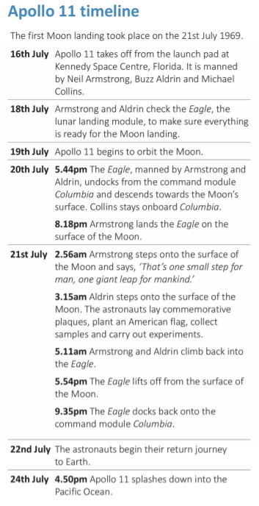  Stonehenge  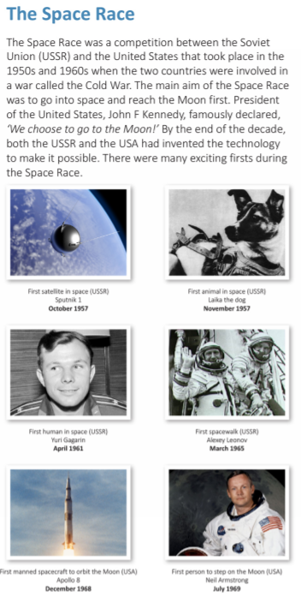  Some people think that Stonehenge was used to study the movements of the Sun and Moon. Other people think it was a place of healing. The ancient Britons believed that the Sun and Moon had a special power over their lives. It is very likely that they held special ceremonies at Stonehenge on Midsummer’s Day (the longest day of the year) and on Midwinter’s Day (the shortest day of the year). |  |  | 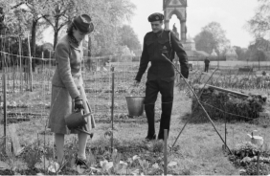  Allotments  Allotments are small pieces of land that individuals can rent to use for growing fruit, vegetables and flowers. The location of allotments in the local environment depends on many factors, including soil quality, drainage, transport links, availability of water and local facilities. During the Second World War there were food shortages and rationing. The Dig for Victory campaign encouraged people to grow fruit and vegetables on open land, increasing the number of allotments by over 70%.  History of Cornish farming  In around 1800 BC, the first farming villages began to pop up and then, with Roman influences, the farming industry grew. When the industrial revolution hit Britain, this was when farming almost went “scat”. But thanks to the application of hydraulics, as well as population booms during the Industrial Revolution, the farming industry survived. With 262,790 hectares of Cornwall’s land still being farmed (which makes up 74% of Cornwall’s entire land area), workers can now plough land, weed plants, and harvest crops much quicker than ever before, catering to Britain’s ever-increasing food demands.  History and changes of farming  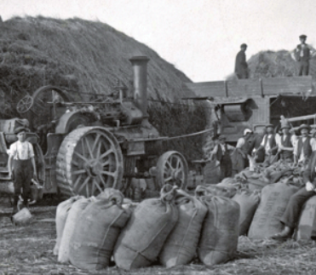  By the early 1800s the invention and use of farm machines pulled by large working horses had changed the way farmers did their work. Later steam, petrol and electric engines helped farmers do their work even better. Because the equipment was better, farmers could cultivate larger and larger fields and produce more crops. Work that had taken weeks, took a couple of days. In 1892 John Froelich, from Iowa in USA, is said to have invented the first petrol driven tractor.  Who was Richard Trevithick?
Vocabulary | Astronomer  Space  Apollo 11  The Space Race  Neil Armstrong  Buzz Aldrin  Michael Collins  Yuri Gagarin  Isaac Newton  Galileo Galilei  Gravity  Newtons  primary source/evidence,  secondary source/evidence,  reliable  extent of change,  extent of continuity evaluate,  reliable,  eye-witness,  legacy  ambiguous,  consequences,  omits,  decade |  |  | Rationing  Allotments  Ploughing  Influences  Steam Engine  John Froelich  Richard Trevithick  Industrial Revolution  Steam  Dig for Victory |  | primary source/evidence,  secondary source/evidence,  reliable  extent of change,  extent of continuity evaluate,  reliable,  eye-witness,  legacy  ambiguous,  consequences,  omits,  decade
Outdoor Learning |  |  |  | Allotment at school

Year 5 Summer Term
 | Summer 1st Half |  |  | Summer 2nd Half
Theme | Bombs, Blitz and Brits |  |  | Where in the World?
British Key Question | Why don’t we speak German? |  |  | Do the British make the best explorers?
Enhancements | WW2 Day  Evacuee speaker |  |  | Travelling speakers  Travelling across Perranporth
Books | Letters from the Lighthouse OR The Emergency Zoo |  |  | Around the World in 80 Days
Addressing Stereotypes | The role of women  Jewish people |  |  | Jules Vern – Foreign stereotypes
British Values | Democracy – What is a dictator?  Rule of Law – Should one person make the rules for the whole country?  Individual Liberty – Evacuation  Mutual Respect & Tolerance – Hitler and the holocaust |  |  | Democracy – G7 Summit  Rule of Law – Different government systems – communism  Individual Liberty – Refugees – choosing to live where is safe  Mutual Respect & Tolerance – Freedom of travel
History  (All NC subject content covered) | Pupils should be taught about:  A study of an aspect or theme in British history that extends pupils’ chronological knowledge beyond 1066 |  |  | Pupils should be taught about:  study of an aspect or theme in British history that extends pupils’ chronological knowledge beyond 1066
Key Historical Skills to be Taught | H-Y5K1.2  H-Y5K1.3  H-Y5K1.4 | H-Y5C2.1  H-Y5C2.2  H-Y5C2.4 | H-Y5I3.1  H-Y5E4.1  H-Y5E4.2  H-Y5E4.3  H-Y5E4.4  H-Y5OC5.1  H-Y5OC5.2 | H-Y5K1.3 | H-Y5C2.1 | H-Y5C2.3
Key questions / knowledge and understanding to be explained  Key Knowledge and facts to be recalled | 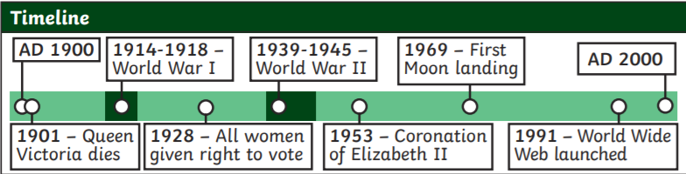  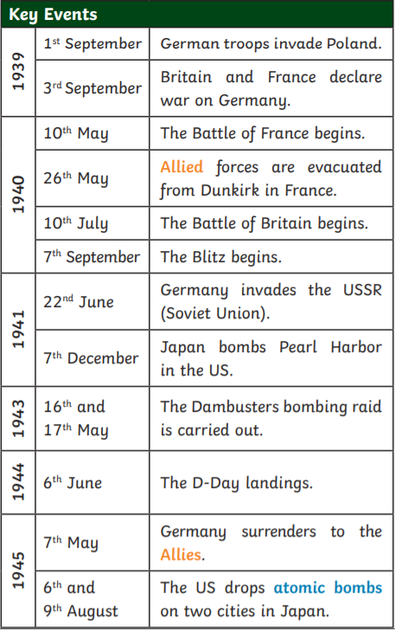  How did WW2 start?  The leader of Germany, Adolf Hitler, had plans to take over other countries. In March 1938, Germany invaded and annexed Austria, which made other countries worried. On 29th September 1938, British, French, German and Italian leaders signed a treaty called the Munich Agreement. This allowed Hitler to annex the Sudetenland (an area of Czechoslovakia) if he agreed not to invade anywhere else. However, in August 1939, Hitler broke the agreement and invaded the rest of Czechoslovakia, followed by Poland on 1st September. Britain, France and Poland had made a pact to support each other, so Britain and France declared war on Germany.  Evacuation  During World War II, over 3.5 million children, along with some of their teachers and helpers, mothers with very young children, pregnant women and people with disabilities, were evacuated from the cities to the countryside, where it was believed they would be safer from bombing. All evacuees had to take their gas mask, ration book and identity card. When they reached their destination, a billeting officer would arrange a host family for them. Evacuation happened in waves, beginning on 1st September 1939. Other waves occurred at the start of the Battle of Britain and at the start of the Blitz.  Rationing  Supply ships were targeted by German bombers and it was necessary to conserve as much food as possible. Rationing meant that each person was only allowed a fixed amount of foods. Ration books were issued, with coupons that showed people how much of each item they were allowed. Shopkeepers would remove or stamp the coupons when they were used. People were also encouraged to ‘Dig for Victory’ and grow as much of their own food as possible. Petrol, soap, clothing and timber were also in short supply. Clothing ration books were issued and people were encouraged to ‘make do and mend’.  The role of woman  Before the war, most women stayed at home and didn’t go out to work. Those who did work were paid less than men and were generally restricted to ‘women’s jobs’, such as nursing or working as a shop assistant. However, when men were called up for active service, women were needed to do jobs such as making weapons, driving buses and trains or working in engineering or shipbuilding. Some joined the armed forces themselves. After the war, many women lost their jobs. However, their experiences led them to campaign for equal working rights and pay so that they could carry on leading more independent lives.  The Holocaust  The Holocaust is the term for the killing of over six million Jewish people before and during World War II, organised by Adolf Hitler and the Nazi party. Even before the war, they wanted to blame the Jews for the problems in Germany and used propaganda to promote widespread public hatred of them. Jewish people were openly bullied, persecuted, abused and discriminated against. Many Jews were sent to concentration camps where they were forced to work like slaves. Many died through infection, starvation or exhaustion. Others were sent to death camps where they were killed in gas chambers. This form of mass killing is called genocide. |  |  | 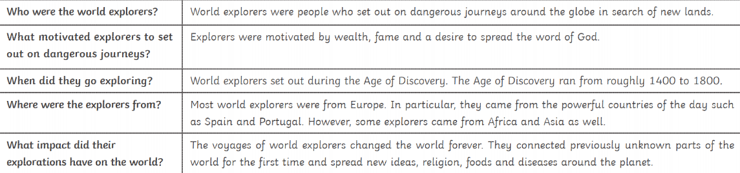  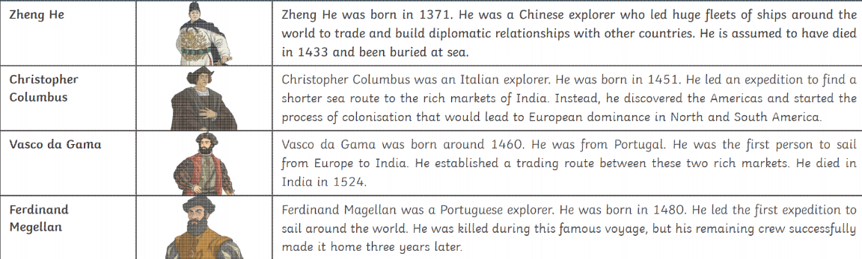  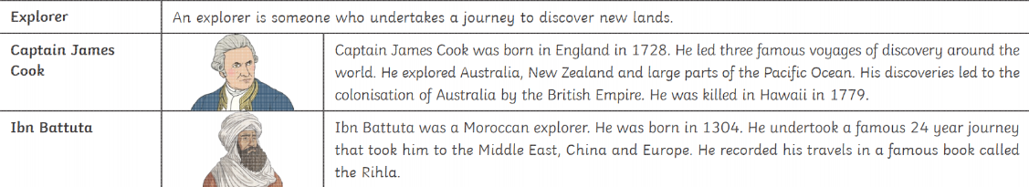  Sir Francis Drake  Drake was the first Englishman to circumnavigate the globe in a single expedition from 1577 to 1580.  Sir Walter Raleigh  A key figure of the Elizabethan era, Sir Walter Raleigh carried out several expeditions to the Americas between 1578 and 1618.  Marco Polo  A Venetian merchant and adventurer, Marco Polo travelled along the Silk Road from Europe to Asia between 1271 and 1295,  Christopher Colombus  Often called the “discoverer” of the New World, Christopher Columbus embarked on 4 voyages across the Atlantic Ocean between 1492 and 1504.  Sir Robin Knox-Johnson  Sir Robin was the first to sail single handed and non-stop around the World between 14th June 1968 and 22nd April 1969.
Vocabulary | Allies  Axis  Nazi Party  Atomic Bomb  Czechoslovakia  Propaganda  Active Service  Holocaust  Genocide  Dig for Victory  Evacuation  Hitler  Winston Churchill  primary source/evidence,  secondary source/evidence,  reliable  extent of change,  extent of continuity evaluate,  reliable,  eye-witness,  Monarchy,  legacy  ambiguous,  consequences,  decade |  |  | Explorer  Sir Francis Drake  Sir Walter Raleigh  Marco Polo  Christopher Columbus  Sir Robin Knox-Johnson  Ibn Buttuta  Captain James Cook  Zheng He  Vasco da Gama  Ferdinand Megellan  Voyage  primary source/evidence,  secondary source/evidence,  reliable  extent of change,  extent of continuity evaluate,  reliable,  eye-witness,  Monarchy,  legacy  ambiguous,  consequences,  decade
Outdoor Learning |  |  |  | Raft Building

