Perranporth CP School
EARLY YEARS STRATEGY for 2022-2023

INTENT
Our Vision:

The Early Years Foundation Stage at Perranporth School is vibrant, fun and engaging, where children are at the heart of every decision we make. Their vitality is nurtured in a friendly and caring environment where happiness and wellbeing are paramount. All our children are known, valued and respected as individuals who leave the EYFS ready for the next stage in their education. Children are encouraged to aim high and make the most of the range of experiences we offer. We believe in providing children with a safe and stimulating environment where children flourish. We pride ourselves on listening to children and those who care for them, using this information to personalise each child’s learning. Learning should be fun, and we believe in first hand learning experiences, valuing the importance of the outdoor environment to develop children’s thinking and problem-solving skills. We are committed to giving our children the best possible start to their school life, teaching them skills which ensure their well-being now and success in the future. We acknowledge that many children start school with below average language skills, and that the Covid-19 pandemic will have exacerbated this. Therefore, we place language development at the centre of all learning, with an emphasis on story sharing at the heart of each topic. We believe that children’s language difficulties are transient and with the right support in place in school, they can catch up.

Curriculum overview – ‘Through learning and Play’

We offer the children a broad and balanced curriculum that follows the statutory Early Years Foundation Stage Framework. We offer a variety of activities, both planned and free choice, which provide opportunities to learn through play.
We run a planned programme of themes throughout the year to ensure that the children are given a wide range of active, real-life and everyday experiences to enhance their learning about their world. These themes/topics are chosen to reflect the children’s interests and include visits in and around the locality and memorable learning experiences.
We offer a mixture of active and quiet times throughout the day, and the children have opportunities to participate in both indoor and outdoor activities.
We aim to have free flow indoors and outside between the classroom and our secure outdoor area. We also plan outdoor session in the school playground and outdoor environment that enable the children to develop skills outside of the classroom.
We take every opportunity to further individual children’s communication skills in speaking and listening.
We encourage the children to look at books and seek opportunities to read stories to, and with them.
We develop early mathematical skills through everyday routines, as well as through planned experiences and games.
We provide activities, which engage the children in problem solving and investigation.
We stimulate the children’s imaginative and creative development through a range of activities, including role-play; a variety of painting, modelling and drawing experiences, both planned and free choice; singing and dancing to music, as well as listening to music and playing instruments.
We encourage the children to make choices and decisions during free play. We also expect them, supported by adults, to take appropriate responsibility for the care and maintenance of resources.

IMPLEMENTATION
Wider Curriculum Planning:
The wider curriculum is planned using a topic-based approach in EYFS. Key aspects that are planned for link to our whole school curriculum intent. Learning is structured within a curriculum that is designed to be engaging and provides experiences and meaningful contexts for learning. Teaching is designed to nurture and challenge our children, underpinned by our school ethos to demonstrate the values of kindness, respect, tolerance and consideration for others. We also want our children to know how to keep themselves safe and healthy.
Me and My Family Light Up the Sky
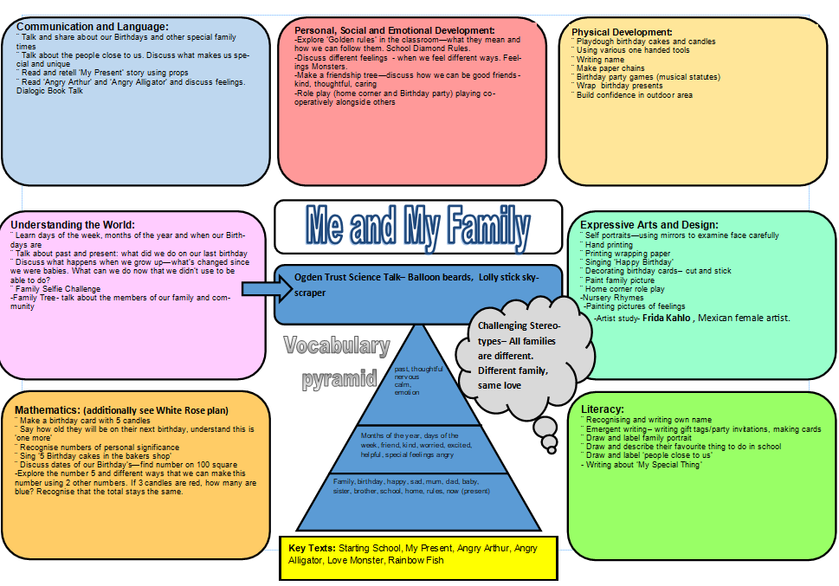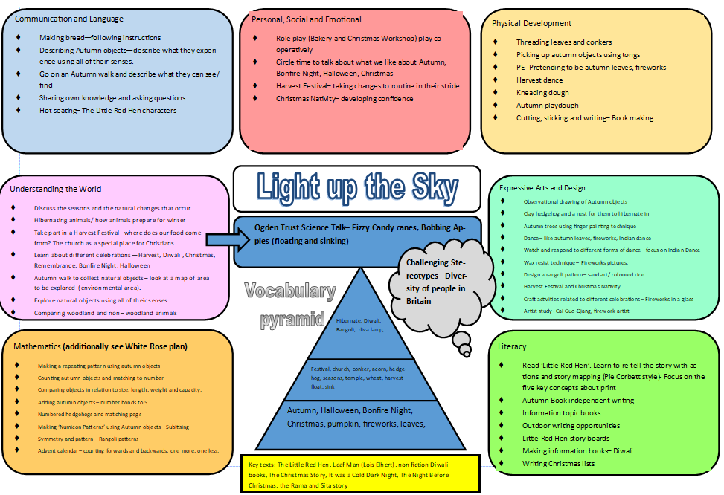
Starry Night Cornwall – Perranporth My Home
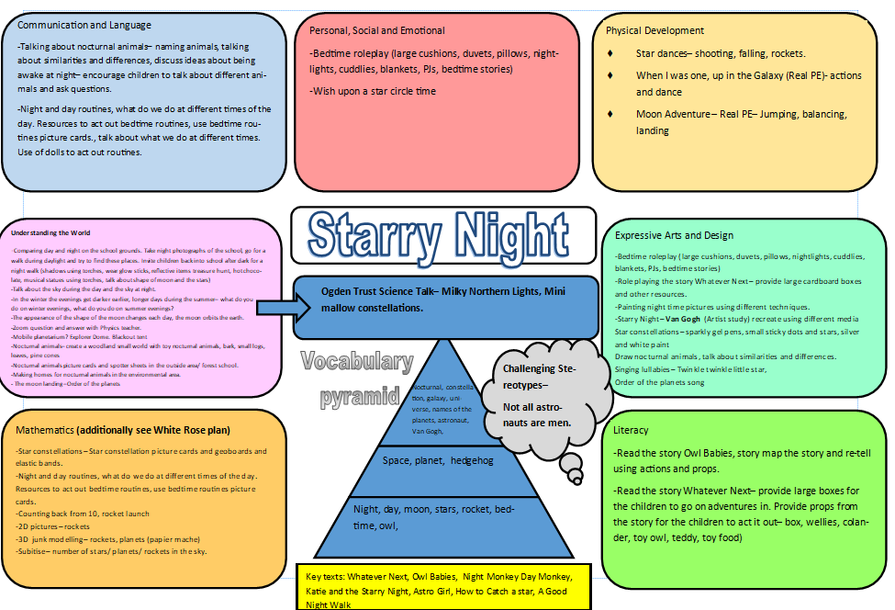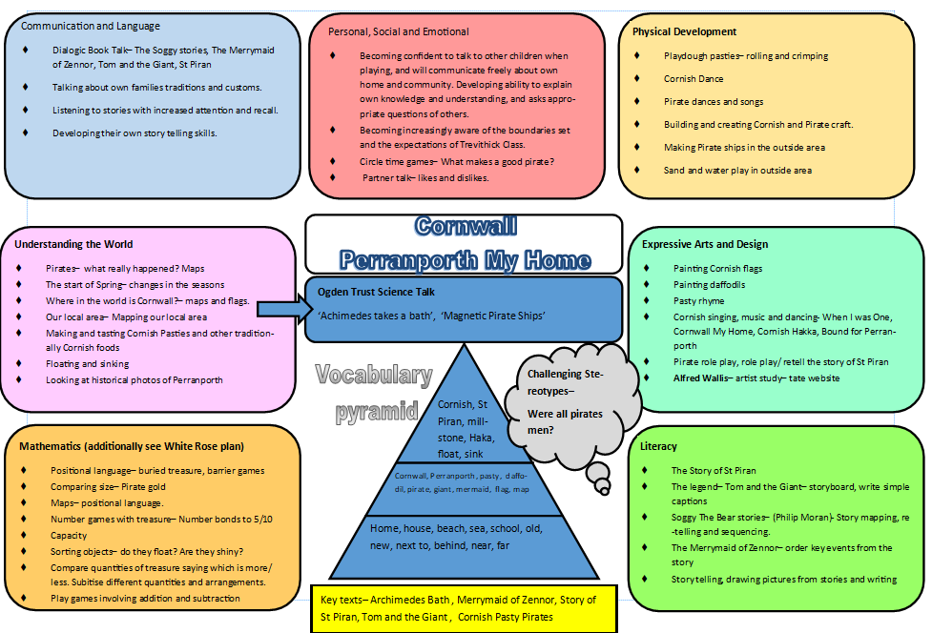
Sunshine and Sunflowers Who Lives in a Rockpool?
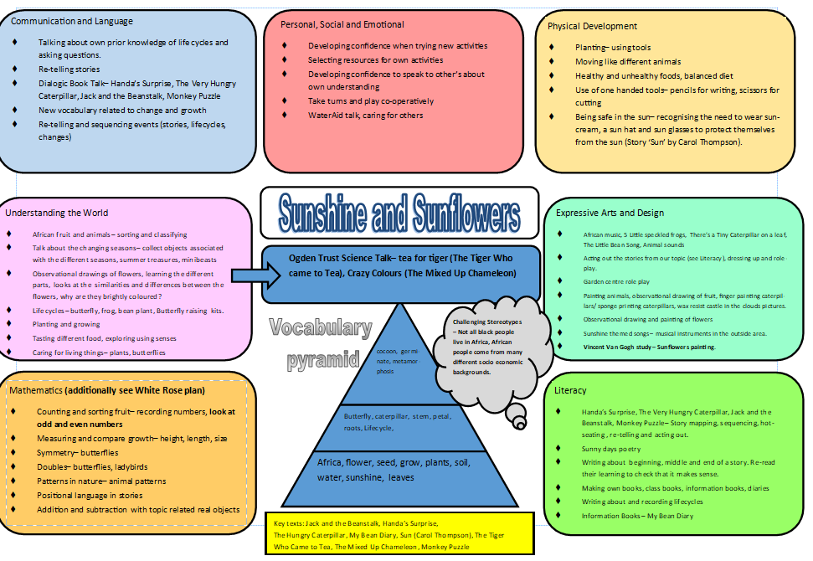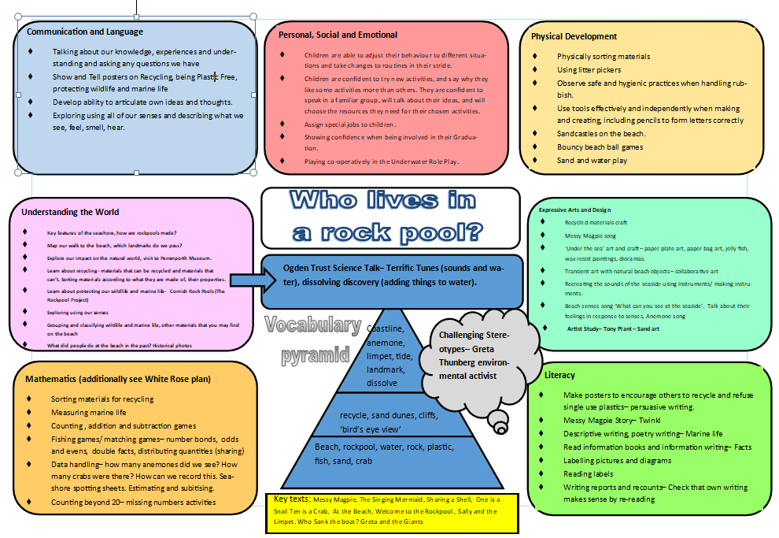

Approaches to developing early language skills, including Phonics
We provide a strong and successful phonic teaching programme where children acquire phonic knowledge in order to become successful in reading and writing. We implement the ‘Read Write Inc’ phonics programme, which enables all children to learn the sounds through a structured and systematic approach.
Each new phase uses and builds on previous knowledge and follows routines that are familiar to the children. Children have books and stories that allow them to practice the sounds that they have learnt and ensure that children become confident and fluent readers. All teaching makes use of multisensory learning styles, and support is provided for children who find phonics difficult.

Approaches to building vocabulary:
- We take every opportunity to further individual children’s communication skills in speaking and listening e.g., show and tell. Pobble 365. What’s in the Box? Dialogic book talk and use of dual coding to help learn new vocabulary.
- We encourage the children to look at books and seek opportunities to read stories to, and with them. Children bring in their books from home to share.
- We use a vocabulary pyramid for each topic (displayed in the classroom) and support the children’s vocabulary development with the use of noun project symbols.
- We assess the children using WELLCOM and send activities home for families.

Books we want our children to love and learn:
Me and My Family
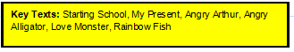
Light Up the Sky
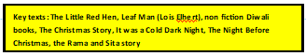
Starry Night
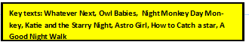
Cornwall – Perranporth My Home
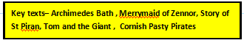
Sunshine and Sunflowers
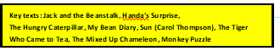
Who Lives in a Rockpool?
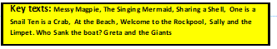
Rhymes and songs we want our children to love and learn:
- Autumn 1 – Head, Shoulder, Knees and Toes, If You’re Happy and You Know It, 1,2,3,4,5 Once I caught a Fish Alive, Pat a Cake, Big Red Combine Harvester, 1, 2, 3, 4, 5 a day, Mr Scarecrow (Out of the Ark) and Here is the tree (rhyme), I have 10 Little Fingers, 1 Finger I thumb Keep Moving.
- Autumn 2 – 5 Little Peas, Remember, Remember the 5th of November, I’m a Little Teapot, Christmas songs.
- Spring 1 – Order of the planets song, Twinkle Twinkle Little Star, Wind The Bobbin Up, Spaceship to the Moon (to the tune of John Brown’s Body)
- Spring 2 – Cornish Haka, Cornwall My Home, Pasty song, When I was one…, ‘Old McDonald’
- Summer 1 – Incy Wincy Spider, Wiggly Woo, There’s a Tiny Caterpillar on a Leaf, Rhyme – First you plant the seed Chant – Fee-Fi-Fo-Fum (use different dynamics), Here is the Beehive, The Little Bean Song,
- Summer 2 – A sailor went to sea, sea, sea, Under the sea song, Beach Senses song, The Rockpool Song, There’s a hole in the bottom of the sea (Barefoot Books)

Approaches to building early mathematical skills

- We develop early mathematical skills through everyday routines, as well as through planned experiences and games. We follow the NCETM Mastering Number planning to develop fluency alongside promoting reasoning and problem solving.
- Priorities are number with an emphasis on place value and counting.
- We provide activities which engage the children in problem solving and investigation.
- Maths is incorporated into other areas of continuous provision.
- We use a range of resources to support and develop early mathematical skills.
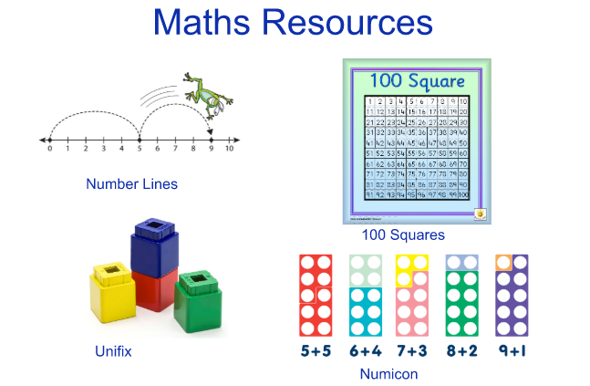

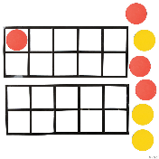
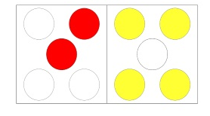

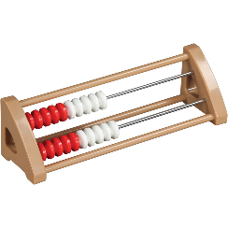
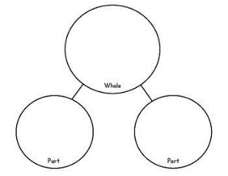

Approaches to all other EY teaching
A vital aspect in the development of essential knowledge and skills is the use of continuous provision. This means that children are using and developing taught skills throughout the year on a daily/weekly basis. We constantly provide enhancement opportunities to engage learners and link to our topics. We encourage children to be independent in the continuous provision through the use of “challenges”. We support children to be intrinsically motivated to complete the challenges and therefore take ownership of their own learning.

Other areas of the curriculum

Personal, Social and Emotional Development
- Introduce Circle Time rules and routines (using family posters)
- Exploring areas of the classroom and outdoor space.
- Naming feelings
- Talking about the things that make us unique
- End of term / reflection – what have I enjoyed / what do I want to get better at

Communication and Language
- Learning rules and routines for circle times
- Introduce talk partners
- Talk for Writing- retelling stories
- Opportunities for language in the role play area

Physical Development
- Learning about lunch time/ snack time. How to make healthy choices.
- Daily gross motor activities (bikes, outdoor equipment etc)
- Daily fine motor activities – out for children to access independently.
- Learning how to store / transport and look after class equipment safely.
- Introduction to gymnastics and different games

Understanding the World
- Talking about what makes us special/unique
- Talking about religious festivals throughout the year: Diwali
- Christian Festivals.
- Use class ICT –IWB, iPads.
- Introduce children to map of the world – where are we from?
- Talk about the seasons – changes in their environment.
- Participate in Ogden Trust Phizzi investigations (Science Talk)
- Explore our local area

Creative Arts
- Daily ‘Wake up song’ / daily opportunities for songs (during circle times) and nursery rhymes
- Explore sound – playing and making instruments/body percussion/voice sounds
- Exploring colour mixing using variety of media – paint, powder paint, fabric. Exploring changes in colour
- Explore portraits – each child to create their own.
- Focus on patterns using different colours.
- Study different artists and create artwork in their style
- Mix media to create different effects
- Work in 2D and 3D (making junk models, clay models)

Transition into Reception

We begin our transition arrangements in the Spring term; the class teachers begin visiting the children at Perranporth Pre-School. We tell the children a story, sing songs and make links with the staff. Once the children have been allocated a place at the school, we contact the families, informing them of key dates and offering a home visit. The class teacher also makes links with children at other providers/settings. After May half term, the children attend daily sessions in Trevithick Class, accompanied by their key worker from Pre-School or their parents.
Transition Arrangements include;
- Home visits (June)
- A Teddy Bear’s Picnic (July)
- EYFS Sports morning (July)
- Daily ‘Stay and Play’ sessions (From May half term until the end of July)
- EYFS end of year assembly (Summer Term)
- EYFS induction meeting at the Children’s Centre (Summer Term)
All children start school on the same day. We do not encourage phased starts!

Engagement and involvement of parents
Parents and carers are kept fully informed about the provision of care, learning and play for their child/ren. We use Dojo to share daily experiences and learning opportunities.
Parents and families have access to information through Class Dojo and they can share their child’s learning through the portfolio.
We hold a ‘Meet the Teacher’ in the first full week to be able to answer any questions and share information with the parents and families.
We hold Family meetings in November and February. There is also a class assembly in July where the children share their learning with their families and receive their Learning Journeys.
In February, we send home a questionnaire to all families to gain a better understanding of our EYFS provision.

Transition from Reception in to Y1
As part of our transition arrangements, we ensure that the children are more than ready for KS1 in a variety of ways. These include.
- Having shared teaching days when the children carousel around different activities. These activities are also delivered in the Y1 classroom and by Y1 staff. This starts in the Autumn Term with a shared Harvest Festival. Other events include the Nativity, Easter celebrations and Cornish day.
- The children have a ‘moving up’ morning in the Summer Term.
- The Y1 teacher will spend time in the EYFS classroom and supporting individual pupils to ensure that the end of year data is accurate.

Timetable
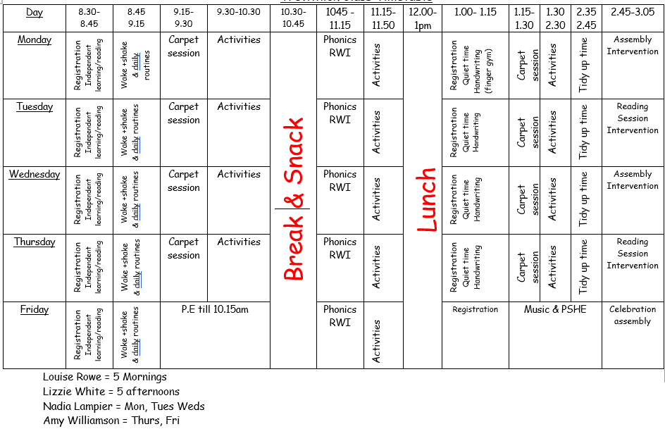
Children have a range of whole class carpet sessions, small group adult directed learning, independent group activities and access to continuous provision.

Approaches to supporting underserved, disadvantaged and SEND pupils

- Dialogic book talk
- Speech and language assessment (WELLCOMM)
- Small group/adapted teaching. In the afternoon session the TA will carry out interventions for RWI and SALT and number interventions.
- The class teacher also implements interventions, both 1:1 and small group for the identified lowest 20%
- Parent workshops – phonics/maths
- PPG children are identified on the daily planning – they have everyday reading, receive QFT and access interventions should they need them.
- Unless a child attends with an EHCP or external agency support in place -we do not put children on the SEN record of need until Y1 Autumn term.

Development of staff expertise
NL has been the EYFS lead for several years. NL went on secondment to the LA to develop 0-5 provision within the County and gain a good understanding of EYFS practice. NL recently attended bespoke EYFS training as part of TPAT INSET day and visited another school within the Trust.
The teaching staff are part of the EYFS Hub within the Trust. Within these groups we carry out focussed research projects this is based upon data from the previous year/cohort e.g. Dialogic book talk to improve communication and language skills and PHSE because there is a focus on managing feelings and behaviour.
Teaching assistants are offered in house and external training e.g. phonics and behaviour. Initial teacher trainees are supported in their teaching practice, this ensures that best practice is observed and upskills all practitioners.

Leadership of Early Years
The EYFS is led by Nadia Lampier.

Safeguarding arrangements
At Perranporth School we have a duty of care to all of our pupils. The Designated Safeguarding/Child Protection Lead and Teacher for Children in Care for Perranporth Primary School is Alistair Johnson (Headteacher), head@perranporth.cornwall.sch.uk
The Designated Deputy Safeguarding/Child Protection Lead cover is Nadia Lampier (Dep HT and SENDCO)

IMPACT
The impact of our curriculum is measured by assessment procedures which allow us to measure outcomes against all schools nationally. We measure the percentage of pupils achieving a “Good level of development‟ (GLD) by the end of the Reception year. The impact of our curriculum will also be measured by how effectively it helps our pupils develop into well rounded individuals who embody our values and carry with them the knowledge, skills and attitudes which will make them lifelong learners and valuable future citizens.

 | GLD % | Reading ELG % | Writing ELG % | Number ELG ELG %
2019 | 77 | 88 | 77 | 81
2020 | 75 | 75 | 75 | 75
2021 | 70 | 73 | 71 | 74
2022 | 70 | 76 | 69 | 79

When children leave the EYFS, not only are they Year One ready, but well-rounded individuals with positive attitudes towards learning.
