Perranporth Primary School Pupil Premium Strategy Statement 2021-2024

This statement details our school’s use of pupil premium funding to help improve the attainment of our disadvantaged and underserved pupils.

It outlines our pupil premium strategy, how we intend to spend the funding in this academic year and the effect that last year’s spending of pupil premium had within our school.
We ensure that teaching and learning opportunities meet the needs of all pupils. We ensure that appropriate provision is made for pupils who belong to vulnerable groups. We recognise that not all pupils who receive free school meals will be socially disadvantaged and that not all pupils who are socially disadvantaged are registered or qualify for free school meals. We conform to the DfE’s guidance that there is no expectation that schools should spend the grant only on eligible pupils, or on a per eligible pupil basis. Our Pupil Premium allocation supports training and continuous development to improve the quality of all teaching, targeting support through interventions and supporting whole-school strategies to improve attendance, behaviour and readiness to learn.

School overview
Detail | Data
School name | Perranporth Primary School
Number of pupils in school | 207
Proportion (%) of pupil premium eligible pupils | 20% (41 children)
Academic year/years that our current pupil premium strategy plan covers (3 year plans are recommended) | 2021/2022  2022/2023  2023/2024
Date this statement was published | September 2023
Date on which it will be reviewed | September 2024
Statement authorised by | Alistair Johnson
Pupil premium lead | Nadia Lampier
Governor / Trustee lead | Helen Goodey
Funding overview
Detail | Amount
Pupil premium funding allocation this academic year | £58,000
Recovery premium funding allocation this academic year | £3,770
Pupil premium funding carried forward from previous years | £0
Total budget for this academic year  If your school is an academy in a trust that pools this funding, state the amount available to your school this academic year | £61,770

Part A: Pupil premium strategy plan

Statement of intent
All pupils at Perranporth School will make good progress in all areas of learning through quality first teaching. We ensure that appropriate provision is made for pupils who belong to vulnerable groups, and they can access a range of interventions to meet their individual needs. Under served pupils are also able to access a wide range of extracurricular activities and enrichment opportunities which will positively impact on their academic achievement and wellbeing.
Our ultimate objectives are:
- To narrow the attainment gap between disadvantaged and non-disadvantaged pupils.
- For all disadvantaged pupils in school to make or exceed nationally expected progress rates.
- To support our children’s health and wellbeing to enable them to access learning.

We aim to do this through
- Ensuring that teaching and learning opportunities meet the needs of all the pupils
- Ensuring that appropriate provision is made for pupils who belong to vulnerable groups, this includes ensuring that the needs of socially disadvantaged pupils are adequately assessed and addressed
- When making provision for socially disadvantaged pupils, we recognise that not all pupils who receive free school meals will be socially disadvantaged
- We also recognise that not all pupils who are socially disadvantaged are registered or qualify for free school meals. We reserve the right to allocate the Pupil Premium funding to support any pupil or groups of pupils the school has legitimately identified as being socially disadvantaged.
Achieving these objectives:
The range of provision the Governors consider making for this group include and would not be inclusive of:
- Ensuring all teaching is good or better thus ensuring that the quality of teaching experienced by all children is improved.
- To allocate a ‘Catch Up’ programme that releases the class teacher to work with small group/individuals focussed on overcoming gaps in learning
- 1-1 support
- All our work through the pupil premium will be aimed at accelerating progress, moving children to age-related expectations.
- Additional learning support.
- Behaviour support and pupil voice
- Enrichment opportunities e.g. school camp, clubs, music lessons, language lessons, educational visits.

Challenges

This details the key challenges to achievement that we have identified among our disadvantaged pupils.
Challenge number | Detail of challenge
1 | Increased parental engagement in reading and home learning
2 | Narrowing the attainment gap across Reading, Writing, Maths and Science
3 | Attainment gap in children achieving greater depth particularly in writing
4 | Attendance and Punctuality issues.
5 | The impact of COVID of pupils social and emotional mental health

Intended outcomes
This explains the outcomes we are aiming for by the end of our current strategy plan, and how we will measure whether they have been achieved.
Intended outcome | Success criteria
Progress in Reading | Achieve national average progress scores in KS2 Reading
Progress in Writing | Achieve national average progress scores in KS2 Writing
Progress in Mathematics | Achieve national average progress scores in KS2 Maths
Greater Depth in writing | Achieve national average for greater depth writing
Other | Ensure attendance of disadvantaged pupils is above 96%

Intended outcomes

This explains the outcomes we are aiming for by the end of our current strategy plan, and how we will measure whether they have been achieved

Intended Outcome | Success Criteria
Pupils make accelerated progress in reading, writing and maths through quality first teaching. | Support for identified pupils will increase access to whole class quality first teaching Gaps between attainment of underserved pupils and their peers will reduce. Pupils will be identified early and put on the APDR cycle if needed.
Pupils falling behind in their phonics receive intensive intervention to secure rapid accelerated progress including pupils with SEND. | Tracking of phonics progress shows that pupils are progressing though the scheme. Pupils achieve well in the PSC. Pupils are ready to come off the scheme in Y2.
Pupils with emotional difficulties are supported by appropriate strategies and opportunities for outdoor learning and therapeutic interventions. | Pupils are happy and settled in school. There are less reported incidents of emotional incidents that interrupt pupils academic learning.
Barriers to attendance are reduced. | Attendance of pupils within vulnerable groups is above 96% The gap between attendance of PP and other groups is reduced. Persistent absenteeism is reduced for all pupils.
Vulnerable pupils are supported to develop cultural capital through a varied range of curriculum supports and experiences. | Pupil voice shows enthusiasm for learning. Outcomes across the wider curriculum positively impact on core subjects Behaviour and attitude to learning is good for all groups of pupils

Activity in this academic year
This details how we intend to spend our pupil premium (and recovery premium funding) this academic year to address the challenges listed above.

Teaching and Learning
Budgeted cost: £ 52,000
Activity | Evidence that supports this approach | Challenge number(s) addressed
PPG pupils receive support, intervention, and booster groups to enable them to make the expected progress and develop their skills and knowledge across the curriculum. | Additional afternoon HLTA across KS2.  HLTA provides cover for class teacher to enable catch up. Small group and 1.1 interventions when implemented effectively can raise pupil attainment. Quality first teaching and working with the support of a teacher has direct impact on pupil’s outcomes. | 2,3
Teachers and TAs to access Welcomm materials  Developing Oracy practice. | Interventions should be carefully targeted through identification and assessment of need. Speech and language is one of the main barriers to learning in reading, writing and the wider curriculum. Research shows that if S&L are targeted, progress can be accelerated. | 2, 3
Quality first teaching for all pupils | Teaching is the top priority and has direct impact on pupil outcome. Maths and English are priorities on the SDP. SENDco time to observe teaching, deliver CPD. SENDco liaises with external agencies to ensure pupils/families are well supported. SENDco creates PPG passports/Padlet and meets with families. | 1,2,3,5
Additional ICT based programs to be used to support learning both at school and at home. | Using online materials to support learning at home can encourage parental engagement. Ruth Miskins Portal, Numbots, RockStars, Purple Mash enable learning at home. There is evidence that tech approaches are beneficial for reading, writing and maths practice. | 1,2,3,,5

Wider strategies
Budgeted cost: £ 9,270
Activity | Success Criteria | Challenge number(s) addressed
Teachers and Ts’s to access Motional materials and implement interventions for SEMH | Social and emotional learning interventions seek to improve pupil’s interactions with others, their understanding of feelings and emotions and their ability to re-engage with academic studies. Emotional literacy interventions help pupils work with their peers, teachers and family. | 2,3,5
Pupils participate in the wider curriculum. | Social skills, independence, resilience and teamwork are developed by taking part in enrichment opportunities e.g. school camp and afterschool clubs. Ofsted research places an emphasis on cultural capital, particularly for disadvantaged pupils. The EEF highlights that participation in sports increases educational engagement and attainment. | 2, 3,4,5
PPG attendance increases | Attendance of PPG pupils is identified and addressed by school leaders and EWO. There is a correlation between attendance and pupil outcomes. | 4, 2, 3

Total budgeted cost: £ 61,770
Review of outcomes in the academic year 2021 -2022
Pupil premium spending allowed the school to provide a range of interventions and further support for underserved pupils (those eligible for PP) throughout the period affected by covid-19 and the aftermath of school closure. Plans and intervention programmes were adjusted, with class teachers leading intervention and catch-up programs whilst also providing remote learning to those children who were absent from school due to the effects of the pandemic. The pastoral support at Perranporth School during this period was paramount, and due to the rising cost of living the school community is aware of the impact this will have on our disadvantaged and under served pupils. The focus for the year 2022-2023 is reading, embedding the school’s new approach to phonics to maintain standards in reading, develop our approaches to the teaching of writing and continuing to support our children and families to ensure good outcomes and raise aspirations.

Pupil Premium Data 2021-2022
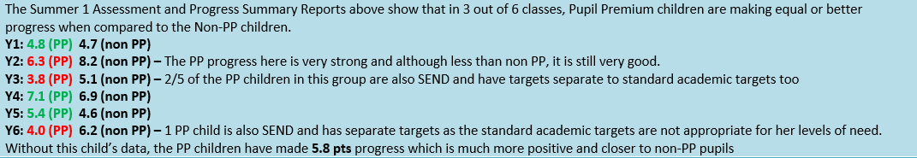
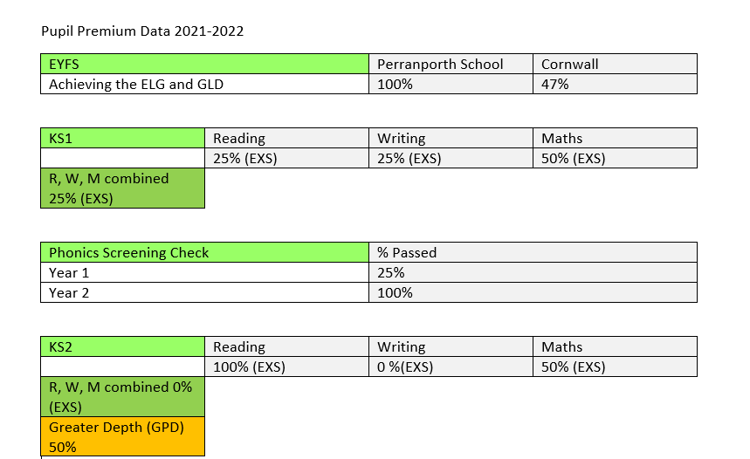
Review of outcomes in the academic year 2022 -2023
The data for our underserved pupils show that they are now closer to non-disadvantaged pupil through the support of this strategy.
Outcomes in 2023 data are improved on 2022 data and show the impact of areas of the support funded through the PPG, such as reading. 100% of Year 1 passed the 2023 Phonics Screening Check. Phonics and reading has been a focus for 2022-23 as the school implemented the RWI phonics programme. External coaching from a RWI trainer and continuous CPD has shown improved, having a significant impact on the teaching and learning of early reading.
90% of KS2 pupils passed the reading test with 57% of underserved pupils passing the combined RWM tests.
Our wider strategies ensured that 23 children attended extra-curricular clubs, children undertook music and Spanish lessons. The school was further able to take children in Y6 on school camp and pay for swimming lessons.

Pupil Premium Data 2022-2023
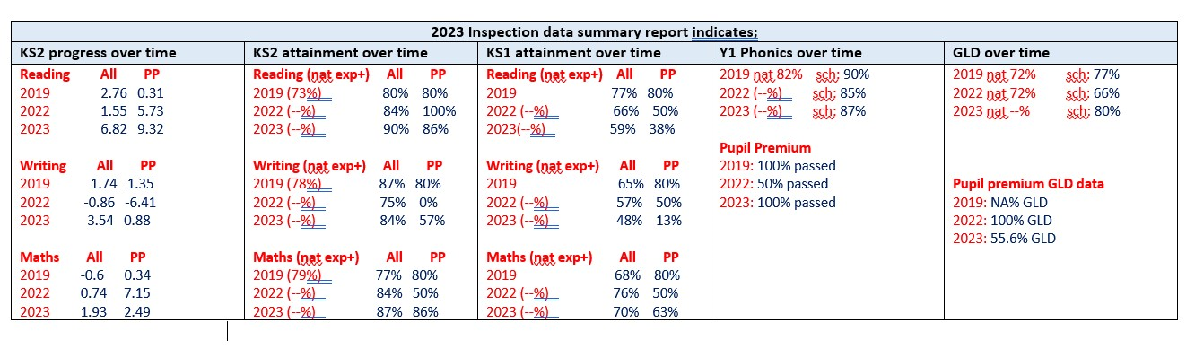
Review of outcomes in the academic year 2023 -2024

