

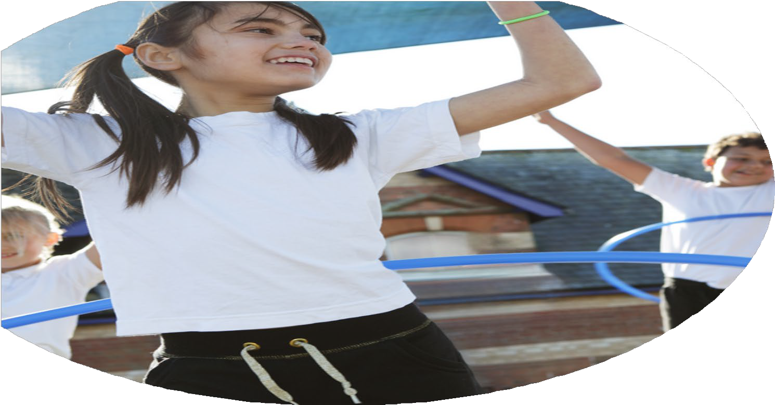
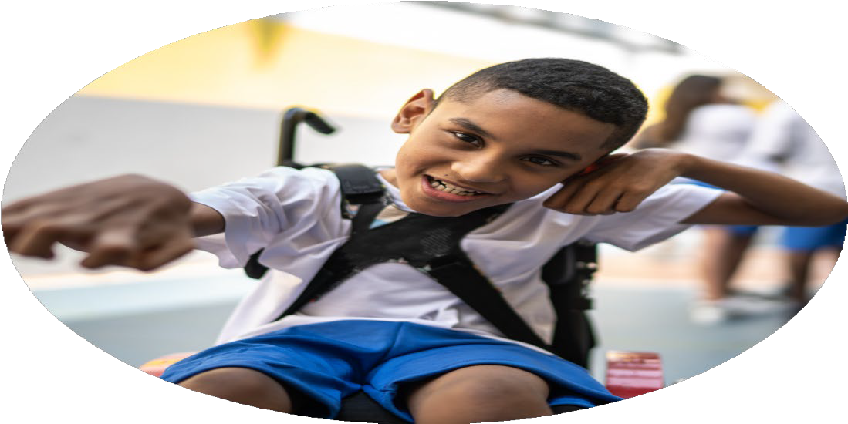




PE Funding

Evaluation Form

Commissioned by

Created by

Images courtesy of Youth Sport Trust

PE Funding Evaluation Form

It is intended that this template should be used as preparation for the completion of the statutory digital reporting tool being introduced this academic year. You can upload data (including swimming) from this template onto this platform once it becomes accessible.
Before you decide how you are going to use the funding for this academic year you should reflect and evaluate the impact of your use of the funding in 2025/26
All spending of the funding must conform with the terms outlined in the Conditions of Grant document. The template is a working document that you can amend/update during the year.
Based on your evaluation of last year’s funding you should decide what you intend to do this academic year, how you will do it, and what impact you expect it to have.

It is important that the funding is used effectively and based on your school’s needs.
You must use the funding to make additional and sustainable improvements to the PE and sport in your school. You must develop and add to the PESSPA activities that your school already offers.

Summative digital reporting from June 2025 will continue to include swimming and water safety information therefore funding can be used to provide top-up lessons where necessary to ensure pupils meet national curriculum swimming requirements.

What are your plans for 2025/26? | How are you going to action and achieve these plans?
Intent | Implementation
Creating confident and competent teaching staff, through the use of CPD. Better support for SEND children in PE lessons, more targeted activities based on assessments. £5,616  Attending school games and intra school events. Staffing and transport. £1,145  Transport for additional swimming lessons. £1,125  NSN and TPAT partnerships. £3,500  All Key Stage Two children to have surf lessons. £2,146.50  Online subscriptions. £1,775  Strengthen the relationship between physical exercise and positive mental health and well being. £376  Additional staff to lead games during lunch times. £1,450 | By using highly skilled external coaches, each teacher will be supported for a minimum of half a term. To support ECTs within the school they will receive a term of support. The coach will be in the lesson and support the teaching, acting as a specialist PE teaching assistant. The aim is that teachers share planning and approach learning in a cohesive way. In lessons coaches to focus on those children, ‘who are behind’. The aim is that the teacher, and the coach will work together on assessments and then address these with targeted activities in the lesson.  Funding will be used to provide transport to allow children to attend intra school competitions.  This will be targeted at Year 5, due to time within the Year 6 curriculum. The benefit of this will be seen in a years time with the Year 6 swimming data.  Through the partnerships the children attended a range of different sporting competitions and staff received support for delivery of curriculum.  Every Key Stage Two child received a surf lesson. This was free of charge to families and is well received by both parents and children.  Full access to Real PE online for the planning, delivery and assessment of Physical Literacy across the school.  We held a school wide colour run to celebrate Mental Health Awareness week.  Staff used at lunch time to support playground games.

What impact/intended impact/sustainability are you  expecting? | How will you know? What evidence do you have or  expect to have?
By creating a more skilled workforce the children will be receiving a higher standard of teaching in their weekly lessons. Staff will be better equipped to assess the children and can then design lessons and activities suited to this. The particular focus on SEND ensures those who need the most support will be receiving the highest level teaching.  After school clubs to have an improved level of equipment and resources to better support high level extra curricular activities.  Children to be given the chance to attend a wide range of school games and intra school events. Transport to such events can be difficult due to location, this will allow for a large number of children to attend.  Transport to and from an additional week of swimming lessons, this is for the children in Year 5 to better support them with achieving the expected level in Year 6.  Attendance to a wide range of intra schools competitions across the year, children to improve their sporting level and for a greater number to be able to experience competitions.  Children to be able to experience a days surf lesson on the beach, giving them a chance to learn a vital skill.  Subscription to Real PE online for support with teaching PE. Access to Padlet, for the use of assessment and monitoring of PE lessons and teaching.  Whole school, staff and children, to take part in colour run to celebrate the end of Mental Health Awareness Week. | Staff feel more confident  SEND children make improved progress  Assessment data  Staff feedback and coaching notes from observations  Number of children attending extra curricular activities  Staff to feedback on improved level of extra curricular activities  Improved aspirations, greater range of experiences offered to all, fair access for those who otherwise would not be able to attend. Number of children who have attended events to increase on previous years.  Higher level of those able to swim 25m.  Number of children who have attended competitions to of increased  Children’s experiences  Feedback from children.  Assessment to be used accurately to monitor learning and development  PE lessons to be monitored  Physical literacy levels to increase across KS1  All children to understand the importance of physical exercise to support mental well being

What impact/sustainability have you seen? | What evidence do you have?
The confidence levels across the staff are far higher than at the start of the year. A lot of time has been spent investing in the new members of staff as it was important to embed them into our way of teaching PE. All members of staff showed increased confidence in teaching PE through both staff surveys and lesson observations. Extra focus on SEND has increased SEND physical literacy.  Increased numbers of children attending extra-curricular activities due to the quality and range of clubs offered. This equipment can be used in future years and the increased levels of physical exercise will have a positive impact upon the children.  By giving children access to sporting competitions we have been able to broaden their sporting aspirations and let them experience competition sometimes for the first time. Children have commented on how much they enjoy these events.  The impact of the additional swimming lessons will not be seen in published data immediately as it was used in Year 5 and not Year 6.  This is an investment in allowing children to grow their culture capital and experience what is a vital skill in our community, but one that can be closed to our most disadvantaged pupils.  Teaching staff able to deliver a high level of teaching across the PE curriculum and able to assess this correctly using video records.  Raised awareness of physical and mental well being across the school will have a long and ongoing impact. | Staff surveys and conversations with staff-  ‘Without the extra support in the first months I would not have known how to teach a PE lesson, I found it extremely daunting but am now confident I can do it successfully.’  Although still behind Age Related Expectations SEND children mad greater levels of progress compared to others. 63% of SEND children made over ‘6 points of progress’ compared to 32% across the rest of the school.  Numbers of children attending after school clubs has increased compared to the previous year, up by 5% across the year. A bigger improvement has been seen in the number of children who have attended more than one club over the year, up by 12%.  More children attended an event this year than last year, 32 more children than 23-24.  The number of children able to swim 25 metres increased by 4 over the week.  Children have commented on how this was their favourite day of the school year.  The evidence of this has been shown through both staff surveys, observations and assessments.  The children have an increased level of understanding in this area, they have noted during pupil conferencing how much they enjoyed this and how it was a part of the year they’d looked forward to.

